Week 01: Project Management & Get Started

How did I decide to make Lucky Ai bot ?
Last year, when I decide to join the Fab acadamy, I got my first idea, that is make a my own Gituar, as a gituar player, feeling it very cool, if I can play a gituar made by myself. However, things changed when I go to Chaihou maker space, the CNC machine is hard to curve such a big size and thiness material, I am thinking if I need find another cool idea. Luckily, I got another idea soon when watch the Chinese Tiktok, I see an Artist made an mechanical hugging device, which when you press the front palte, the arm will hug you. Wow, pretty cool with humanistic care, That is the thing I want. I was told be by Mentor, Matthew Yu, you need to add some electonics to the hugging device, I didn't find a good idea to combine the electroincs with the machanical arm. Maybe I need to find another idea. To be honest, a long time, more than 1 month, I didn't got any inspiration, then Anxiety and Confusion crash me, as time passed day by day. Finanly, my mentor, Matthew saved me. maybe you can make a Ai voice interaction device, the idea catch me. I am working in Seeed, we have already released many AI gadegts, and I received many inqiury from my customer before, Why not I made one by myself ? OK, that's it.

Talking with Gemini to finalize the PRD
without any background/ expeirence on products, Ai will be a good assistant to help me analsys and define the device. I need to find balance between my capabilty and time. I remove some feature, like the Ai bot could walking on my desk with wheel, and remove some features as the MUC don't have enough Pins for connection. Finally, I finanlized the definition of the AI bot,

In my mind, it is desktop Ai acompanion bot with voice interaction feature with Ai model, and expressive interaction like emoji.
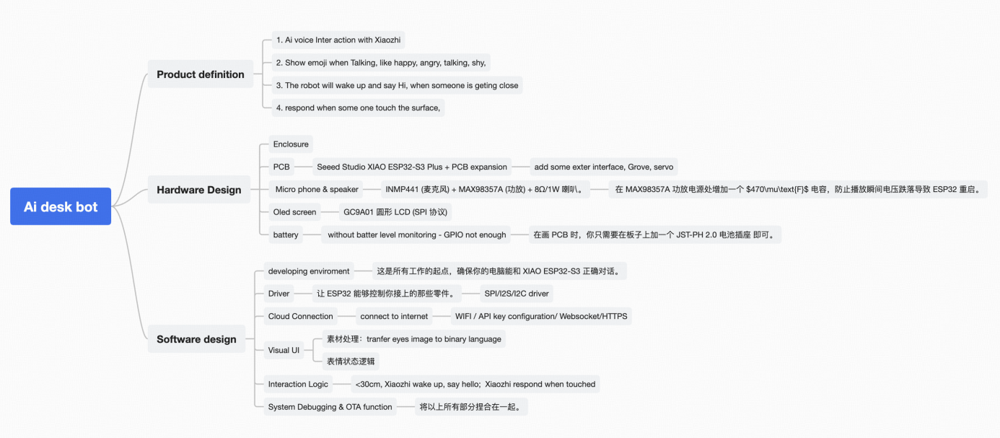

With my limited knowledge about electonics, I feel the Seeed Xiao ESP 32 could be the MCU for this project, as Seeed has a similar item Wacther, using the the Same MCU too, with confirmaion with genmini, I got a list of the hardware, as show in the pciture above. Same with Software, Gemini breakdown the software development in 6 parts.

When I finalise the definition, I wanna know who will lt be, with the prompt " regarding you as a Indistrail Designer from Apple, with understanding on the PRD, to design the enclosure, with simplify design langauage, suitable for 3D priting, integrate with a circle display, desktop scenario, I got 2 amazing effect image, as below.

My communication with gemini, https://gemini.google.com/share/3960e3806e06

Making the first website and release
When I finish the PRD of my final project, it is time to build my website, the first website in my life, haha.
I don't know how to do, no idea what is the steps to build the website and release to Gitlab, I don't know many things. Gemini saved my, he teach me steps by steps, he looks like a exprience Fablab menber, giving every details, from build enviorment, install Phython, download software Visual Studio Code, basic knowledge of MKdocs, how to coding on VSC, and git push.

The general steps will be, according to my communication with Gemini,
- install tool, VS Code( Visual studio Code) and Git
- use SSH key connect my laptop with gitlab
- Clone the cloud-based file to the local environment
- Configure MK docs on VS code
- use VS code to edit the website and release.

Steps looks easy and clear, when I finish, but it really time consuming, there is many small issue, or problem coming out, for the confirguration. Luckily, Gemini konw how to solve all the problem. See below, it is the MKdoc.file for the website.
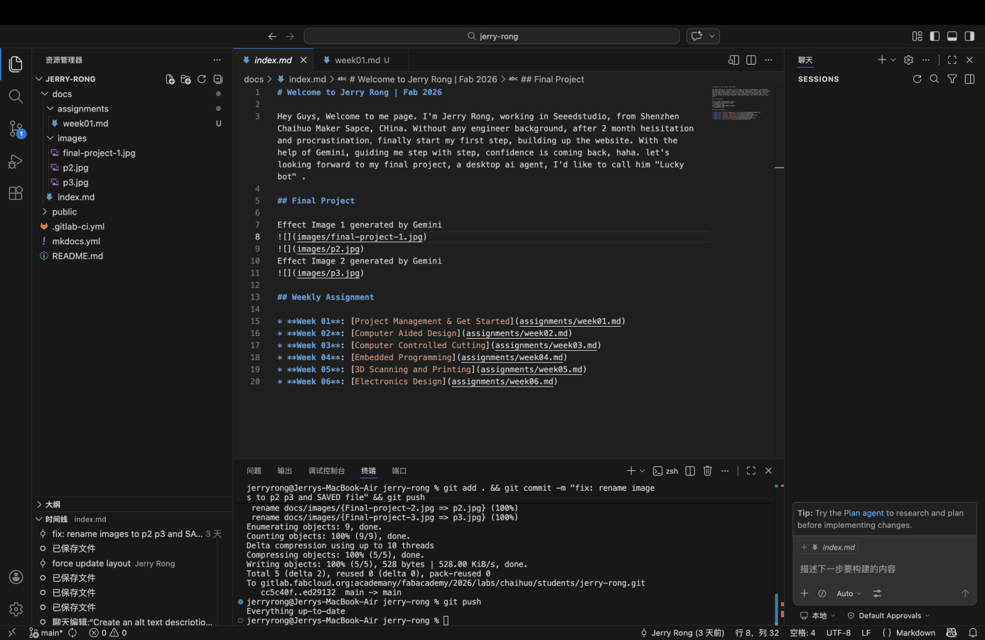

All communication happened in Gemini, https://gemini.google.com/share/fd868e8711ef

I cannot list all the issues I debuged, I just wanna share one, there is 2 Images, I need to upload to the website, it takes me around 90 minuties to debug the problem,they are some very basic problem, like rule of file name, no capital letter, use "-" between words, rather than blank space. I almost feel frustrated, spending 90 minutes to debug the small issues, again and again. Finally, Gemini tell me rename the file of image, then succeed. As below, I release the website again and again.

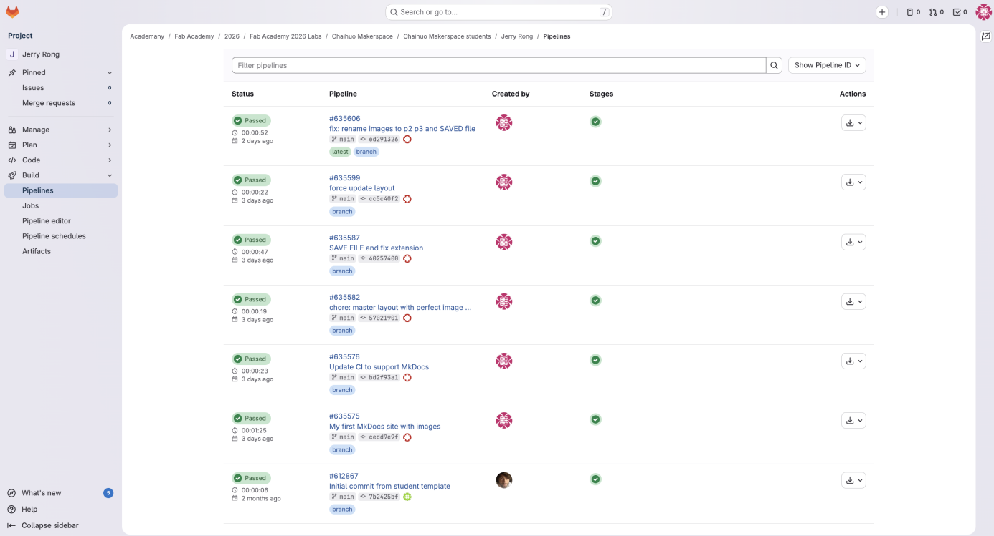

See my website, below,
