Buildbee 3d printing 2.20.25 (15 step Process)

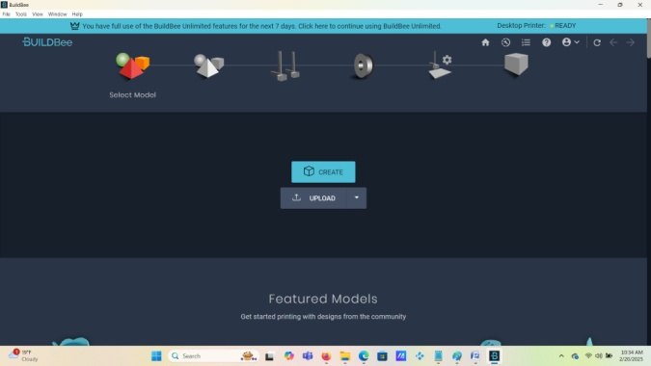

1. Open the Buildbee program from the desktop of your pc screen (or web browser)

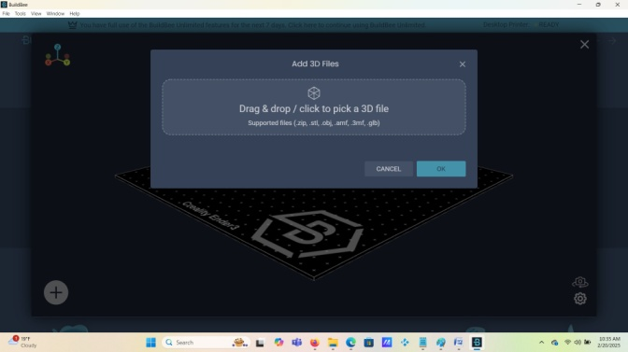

1. **On this step you must now select the file that you are going to load**

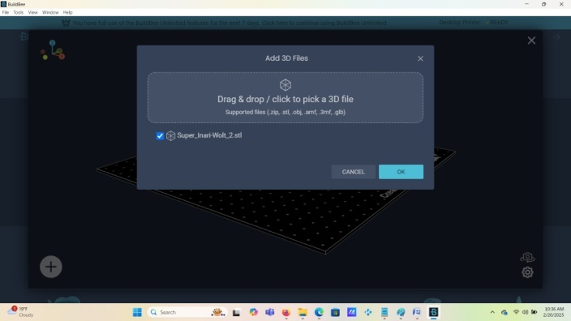

1. **Confirm the selected file and press OK**

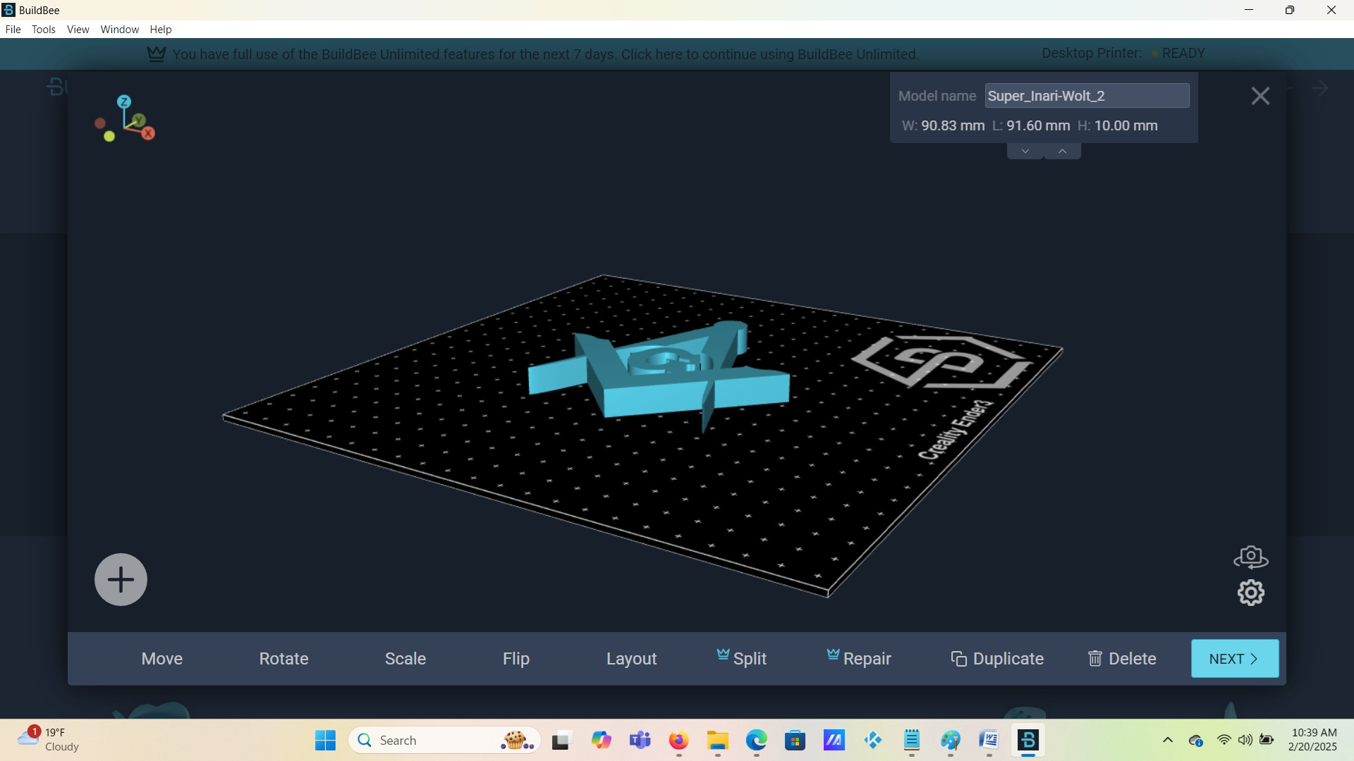

1. View the 3d model and click the next button

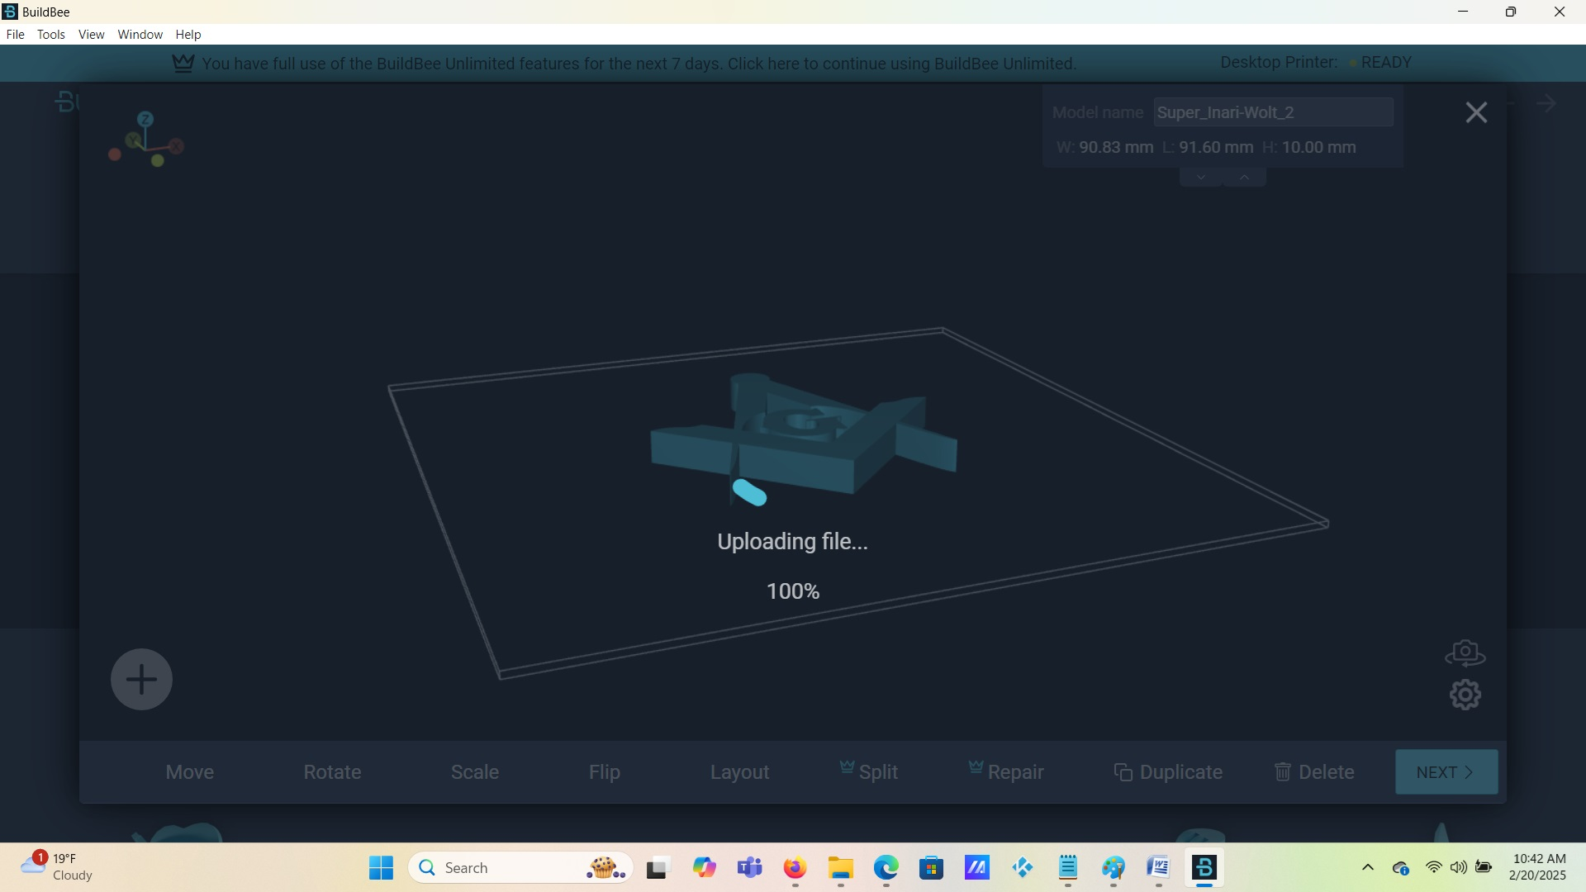

1. File has been uploaded to project tray

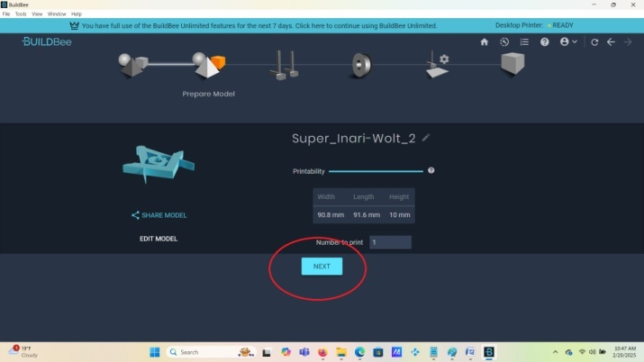

1. Model is uploaded, now click next

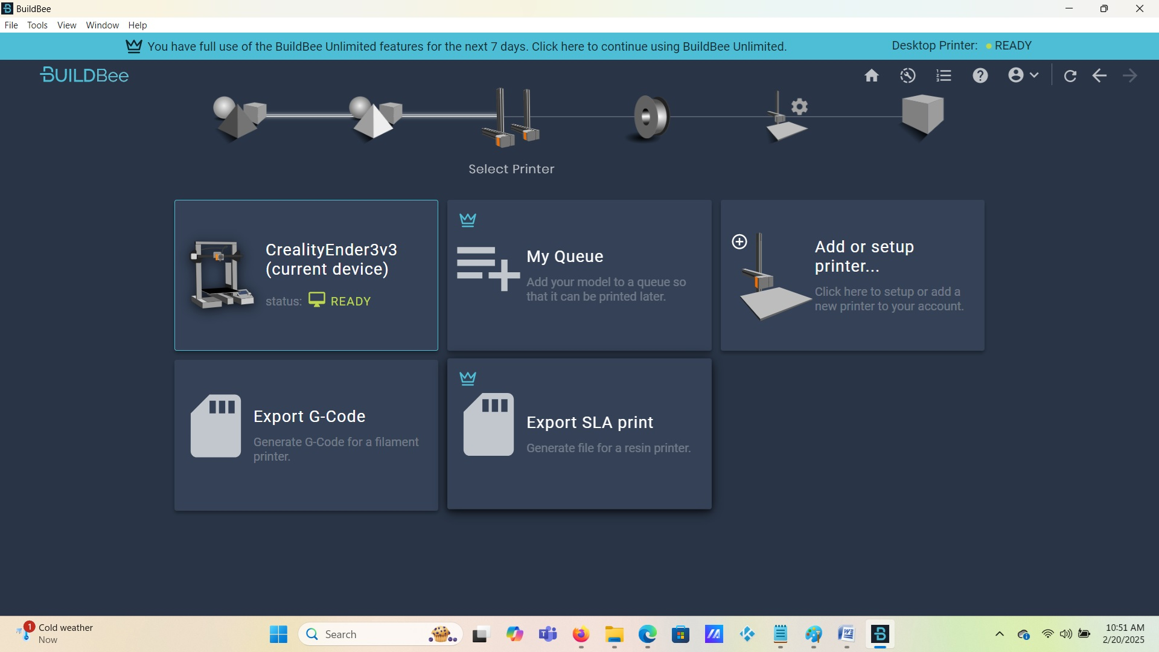

1. Select the printer or storage medium of your choice

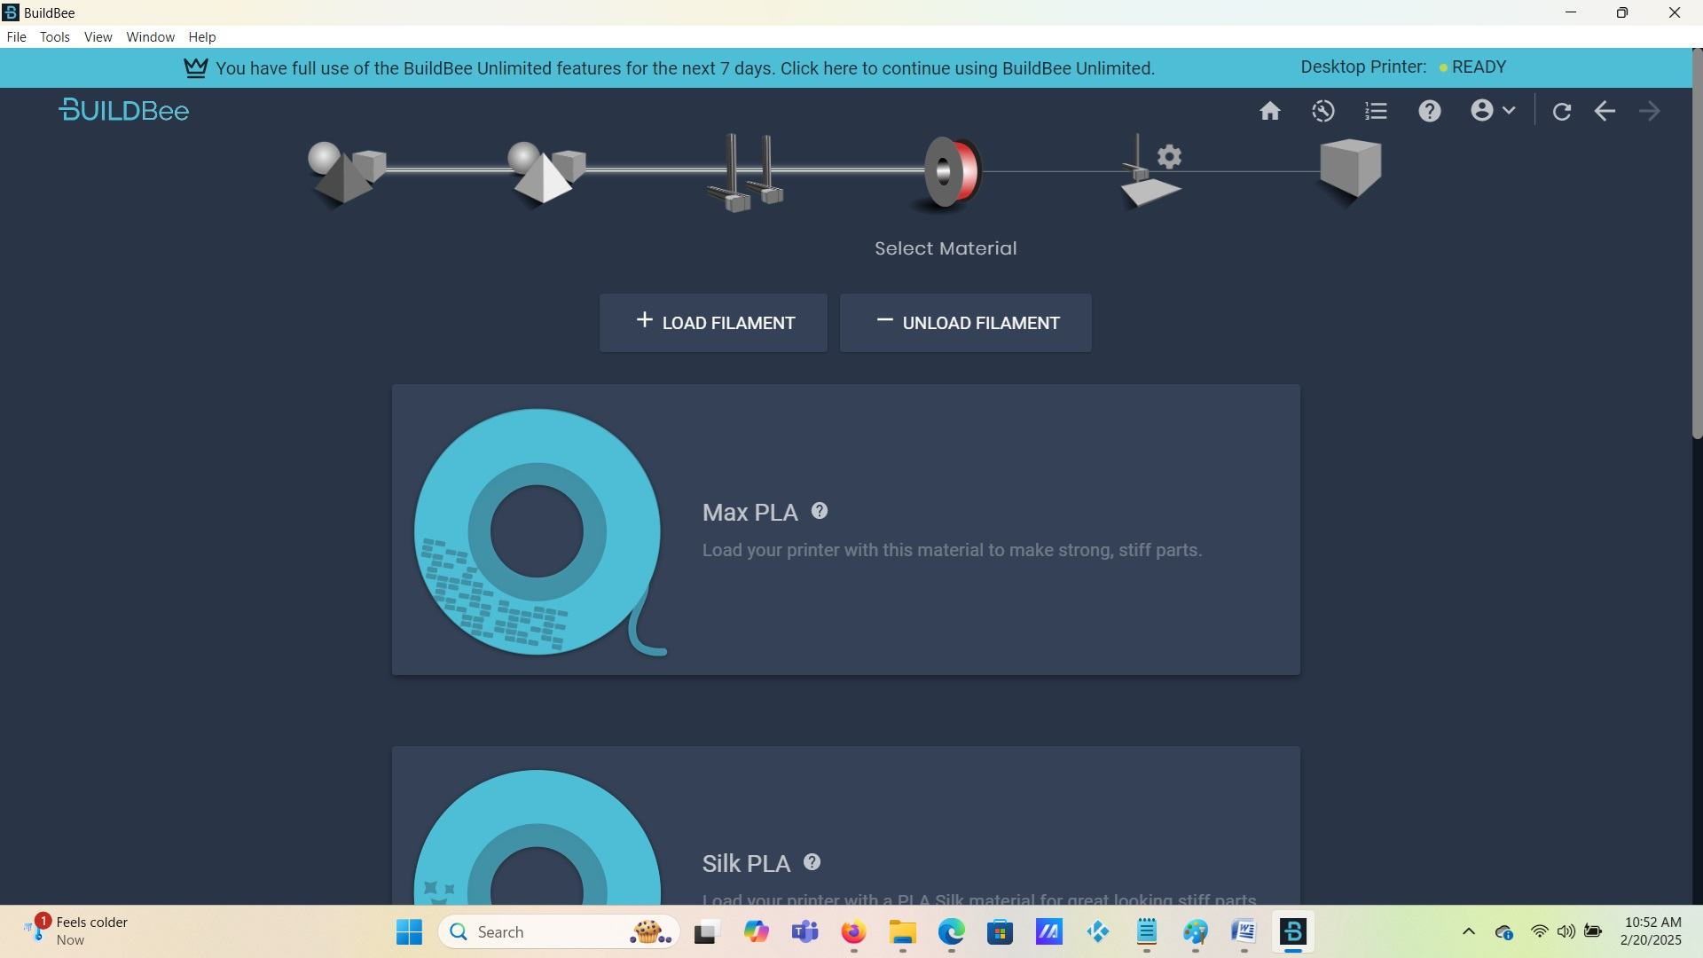

1. Select the Filament that you will use for your print

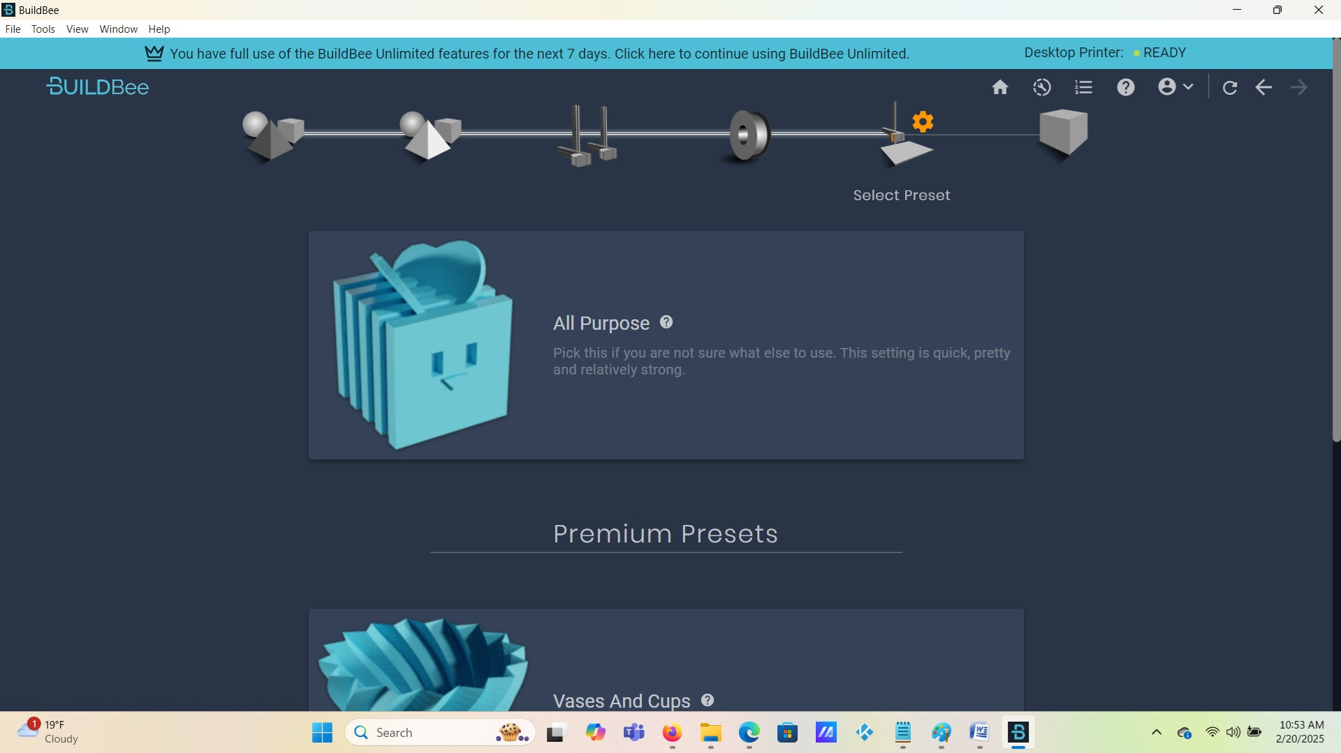

1. Confirm the printing preset

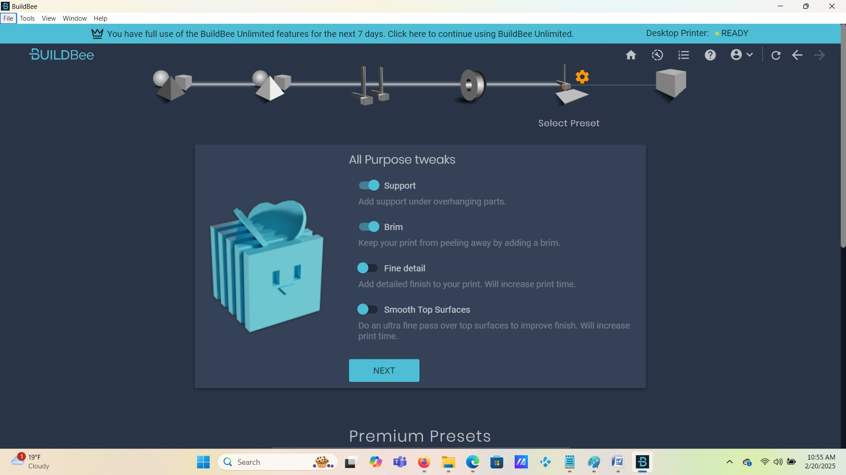

1. Check last minute tweaks

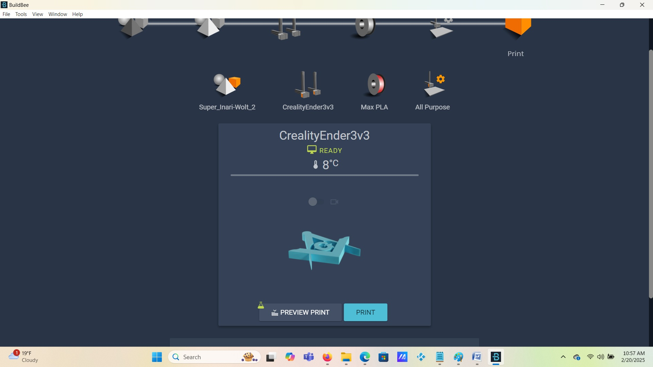

1. Check preview and click when ready

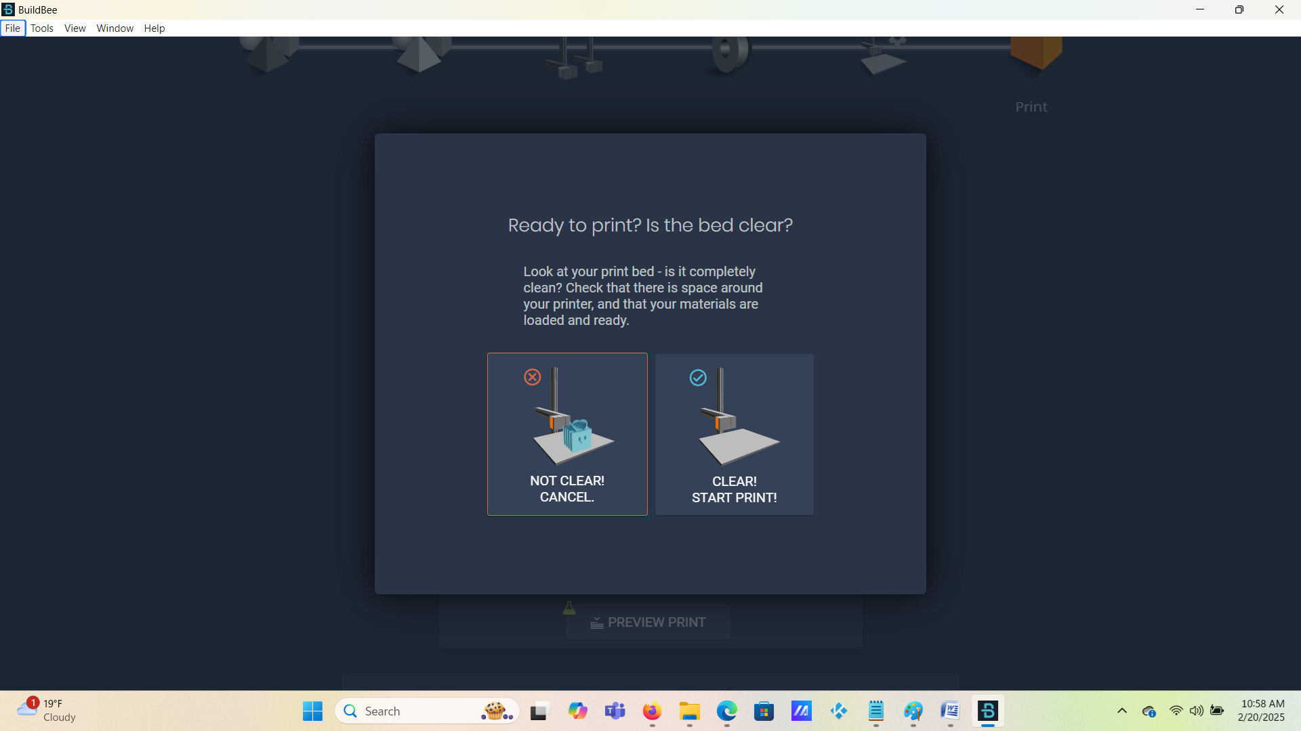

1. Clear bed before starting

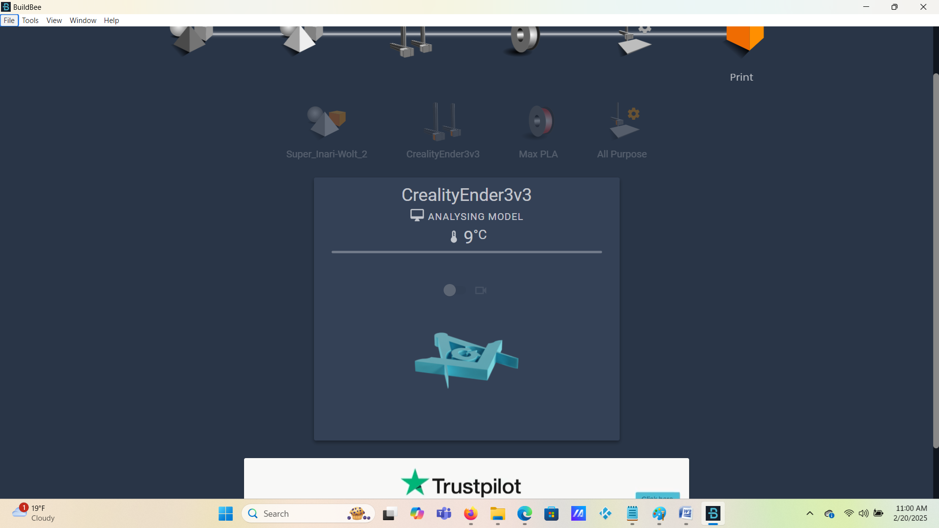

1. Creality will self align head

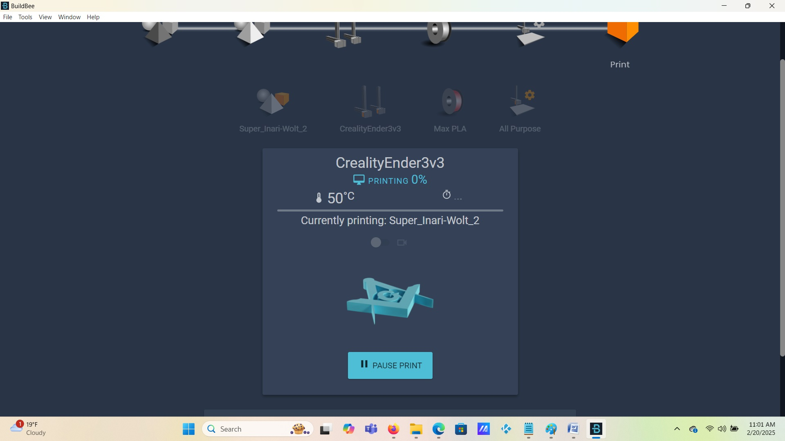

1. Analyzing the image

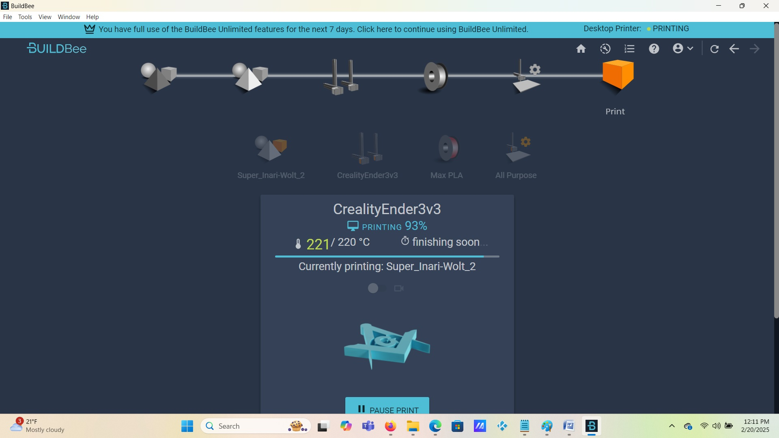

1. Project almost finished



1. Print is finished and extra molding was removed.

The job was 1 hour and 10 minutes long.

If you need help getting buildbee on your pc here are a few instructions that will help.

Using BuildBee Desktop

1. Install BuildBee Desktop on your computer
2. Connect the 3d printer to the computer with a USB-C cable
3. Open the BuildBee Desktop app
4. Sign in or create an account
5. Click the setup banner
6. Run the connection wizard and follow the prompts