1.MILLING:
Milling is a machining operation in which a workpart is fed past a rotating cylindrical tool with multiple cutting edges.
_{The} axis of rotation of the cutting tool is perpendicular to the direction of feed. This orientation between the tool axis and the feed direction is one of the features that distinguishes milling from drilling. In drilling, the cutting tool is fed in a direction parallel to its axis of rotation. The cutting tool in milling is called a milling cutter and the cutting edges are called teeth.
2. TYPES OF MILLING OPERATIONS
There are two basic types of milling operations,
(a) Peripheral milling
(b) Face milling.
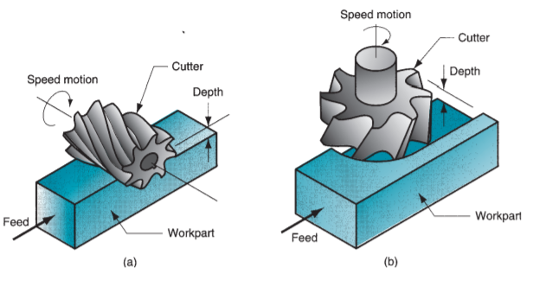

Peripheral milling
In peripheral milling, also called plain milling, the axis of the tool is parallel to the surface being machined
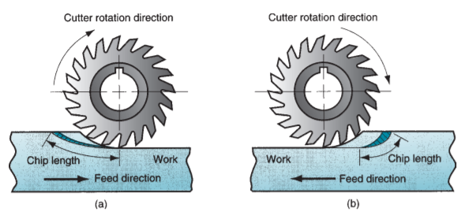
Face milling
In face milling, the axis of the cutter is perpendicular to the surface being milled
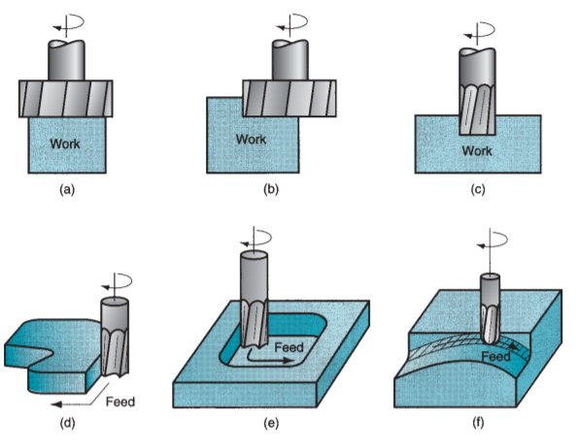
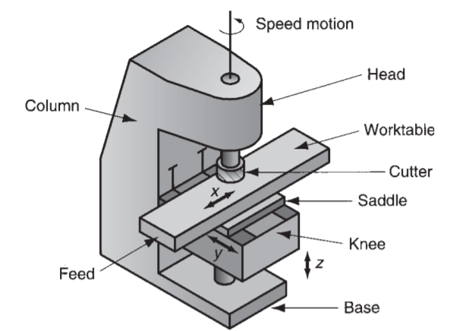

CUTTING CONDITIONS IN MILLING
- Spindle speed
The cutting speed is determined at the outside diameter of a milling cutter. This can be converted to spindle rotation speed using a formula that should now be familiar:

N= (12 × V)/ (π ×D) ………………Eq.1
V: is the recommended peripheral velocity for the tool being used
D: is the diameter of the tool
N: is the rotational velocity of the tool R.P.M

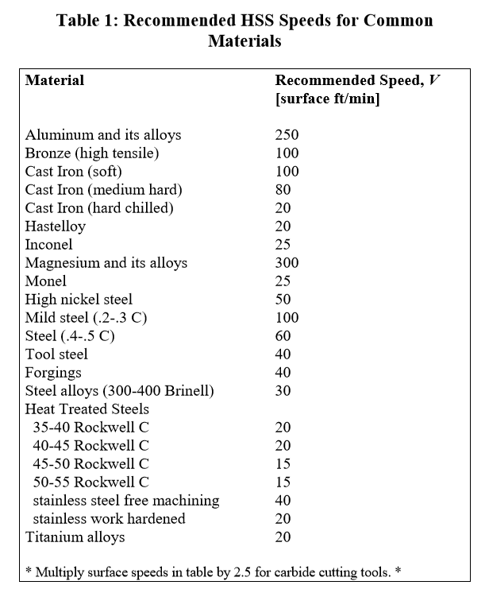

_____________________________________________________________________________________
2. drilling feed (plunging)
f = N × fr…………Eq. 2

where f = calculated linear feed rate of the drill [in/min]
N = spindle speed [rpm]
fr = feed per revolution of the drill [in/rev]
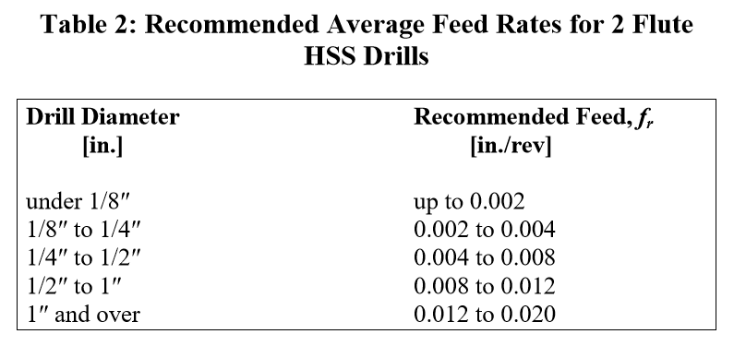
_____________________________________________________________________________________
3. Cutting Feed Rate
The feed f in milling is usually given as a feed per cutter tooth, called the chip load, it represents the size of the chip formed by each cutting edge. This can be converted to feed rate by taking into account the spindle speed and the number of teeth on the cutter as follows:
f = N × ft × m………….Eq.3

where f = linear feed rate of the end mill / cutter [in/min]
N = spindle speed [rpm]
ft = feed per tooth of the end mill / cutter [in/tooth]
m = number of teeth on end mill / cutter [integer
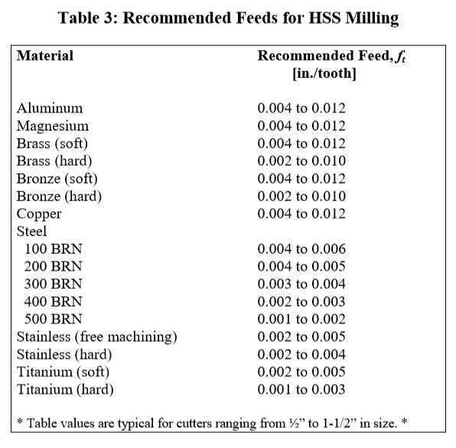

Example1 : Calculate the speed and feed for a ¼″ HSS drill bit in soft cast iron on the CNC milling machine in the lab.
Sol: from tables GIVEN SFM =100 for cast iron and Fr Recommended for ¼”= 0.004
N [rpm] = 12 × V / (π × D) = 12 in/ft × 100 ft/min / (π × 0.25 in/rev) ≈ 1500 rpm (ans)
F [in/min] = N [rpm] × fr [in/rev] = 1500 rev/min × 0.004 in/rev = 6.0 in/min (ans)
_____________________________________________________________________________________
Example2: Calculate the speed and feed for a 1″ diameter, 4 flute HSS endmill in aluminum using Tormach milling CNC in the lab.

First, lookup the recommended surface speed (peripheral velocity) in the appropriate literature (Table
V ≈ 250 ft/min
Next, calculate the spindle speed from Equation 2:
N [rpm] = 12 × V / (π × D) = 12 in/ft × 250 ft/min / (π × 1 in/rev) = 950 rpm (ans) Finally, calculate the feed rate using Equation 3, given that the appropriate initial feed per tooth (chipload) is ft ≈ 0.008 in/tooth (from Table 3):
f [in/min] = N [rpm] × ft [in/rev] × m = 950 rev/min × 0.008 in/tooth × 4 teeth/rev = 30 in/min (ans)

________________________________________________________
Once again, the initial choice of speed and feed will be at the lower value of the ranges listed and will ultimately depend upon the following variables:
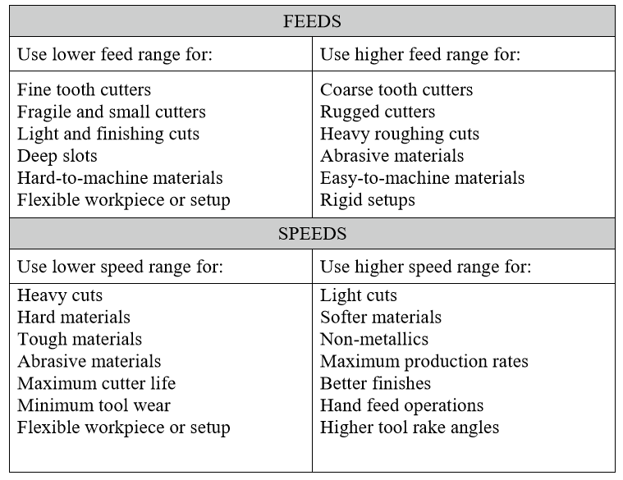
Types of cutting tools materials
- High speed steel (HSS)
General use of HSS is
- Tungsten is used to increase hot hardness and stability.
- Chromium is used to increase strength.
- Vanadium is used to maintain keenness of cutting edge.
In addition to these 2.5% to 10% cobalt is used to increase red hot hardness.

- H.S.S is used for drills, milling cutters, single point cutting tools, dies, reamers etc.
- It looses hardness above 600°C.
- Some times tungsten is completely replaced by Molybdenum.
- Molybdenum based H.S.S is cheaper than Tungsten based H.S.S and also slightly greater toughness but less water resistance.

- Carbide
- Produced by powder metallurgy technique with sintering at 1000°C.
- Speed can be used 6 to 8 times that of H.S.S.
- Can withstand up to 1000°C.
- High compressive strength is more than tensile strength.
- They are very stiff and their young’s modulus is about 3 times that of the steel.
- High wear resistance.
- High modulus of elasticity.
- Low coefficient of thermal expansion.
- High thermal conductivity, low specific heat, low thermal expansion.

- Ceramics
- Ceramics and sintered oxides are basically made of Al₂O₃, These are made by powder metallurgy technique.
- Used for very high speed (500m/min).
- Used for continuous cutting only.
- Can withstand upto 1200°C.
- Have very abrasion resistance.
- Used for machining CI and plastics.
- Has less tendency to weld metals during machining.
- Generally used ceramic is sintered carbides.
- Another ceramic tool material is silicon nitride which is mainly used for CI.

- Polly crystalline diamond
- Diamond has
  - Extreme hardness
  - Low thermal expansion.
  - High thermal conductivity.
  - Very low coefficient of friction.
- Cutting tool material made of diamond can withstand speeds ranging from 1500 to 2000m/min.
- On ferrous metals diamond are not suitable because of the diffusion of carbon atoms from diamond to work-piece.
- Can withstand above 1500°C.
- Diamond with polycrystalline structure is recently introduced and made by powder metallurgy process.

